PLASMIX

Plastics Derived Fuel

PLASMIX
Summary
Sample pictures
Provisional Lab test report

Summary
Plasmix is a fuel produced from various types of selected plastics, categorically excluding PVC. It constitutes the non-further recyclable portion of solid wastes, industrial wastes or commercial wastes.

Material | Plasmix
Description | Mixed soft plastics, produced by collection and baling of non-recyclable plastics (not including PVC), labels, and other soft plastics materials.
Packaging | Bales, abt cm 70x120 (indicative, any industry standard size allowed)
Aspect | Solid
Individual pieces size | Up to 40-50 cm each
Classification | EWC code 19.12.04  HS Code (TARIC) 39159080  Annex VII regimen, green list
Recovery | Delivered strictly for recovery by Waste Framework Directive (2006/12/EC) method R1, energy recovery. Final plant to be certified for R1 operations.
Shipment | Depending on departure location for each producing plant:  - bulk baled in 2000-2500 metric tons vessel;  - bulk baled in 40’ sea containers (abt 20 metric tons per box)

Sample pictures

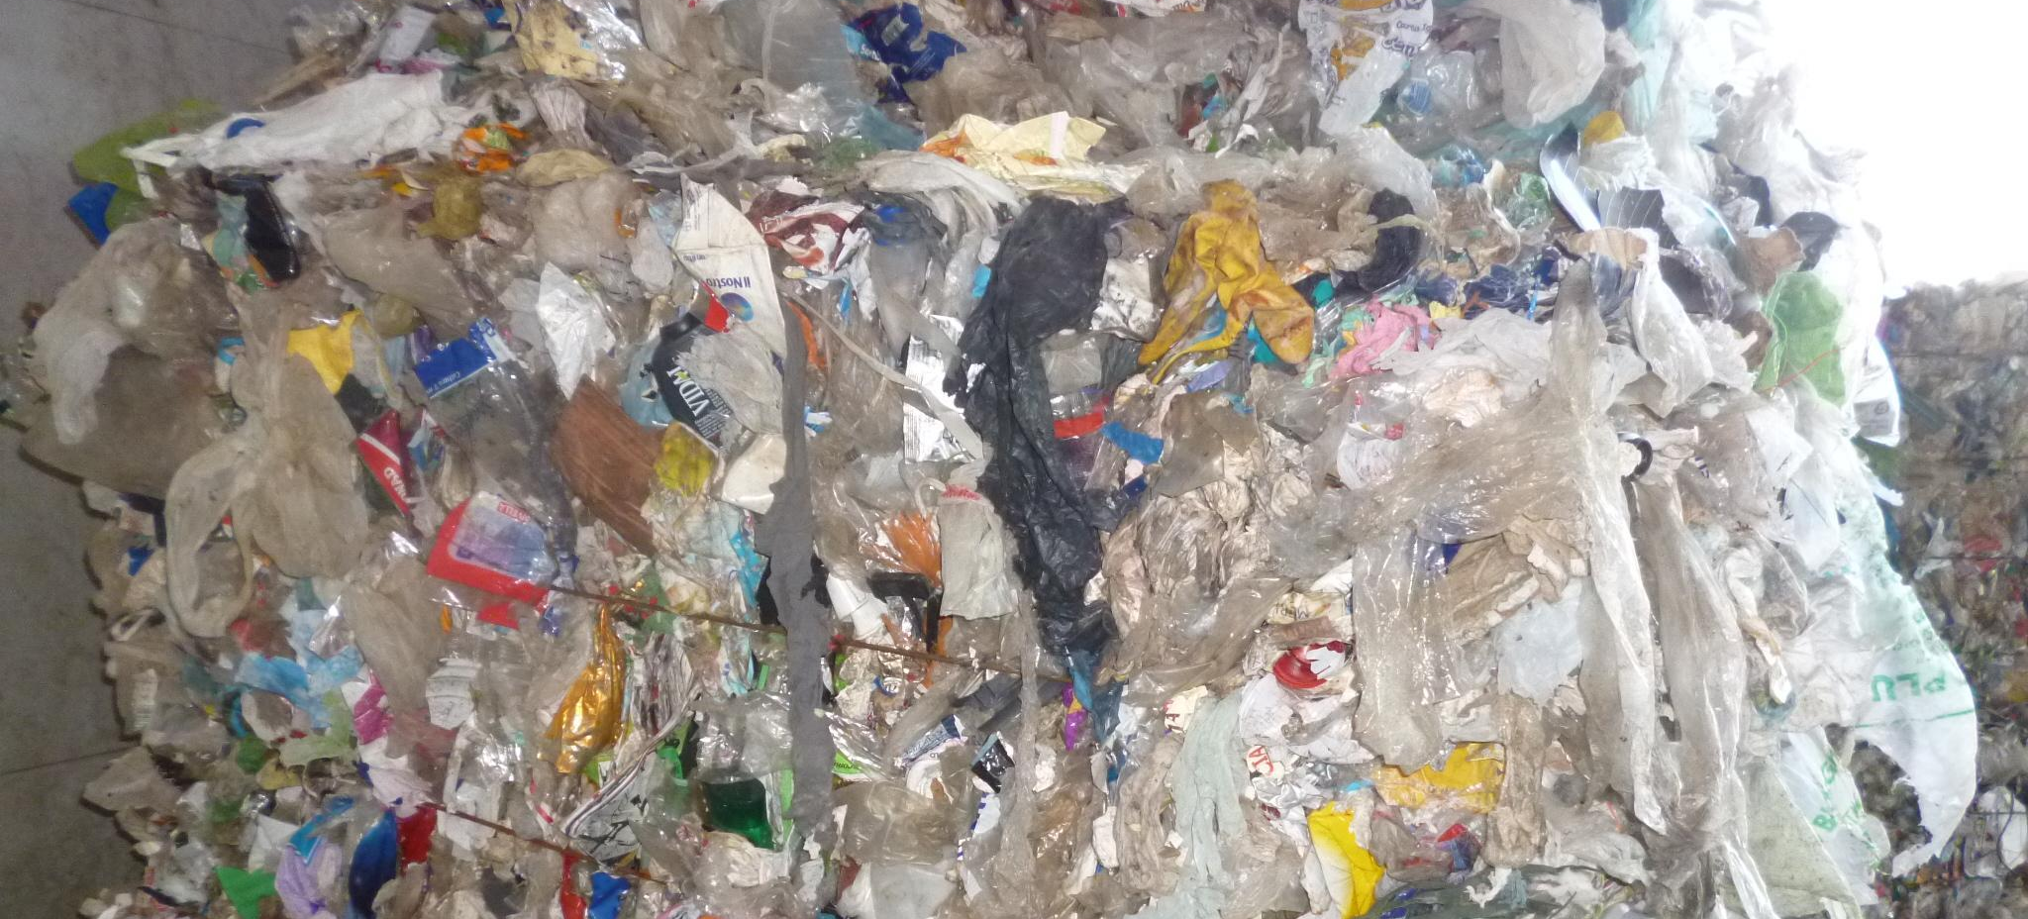

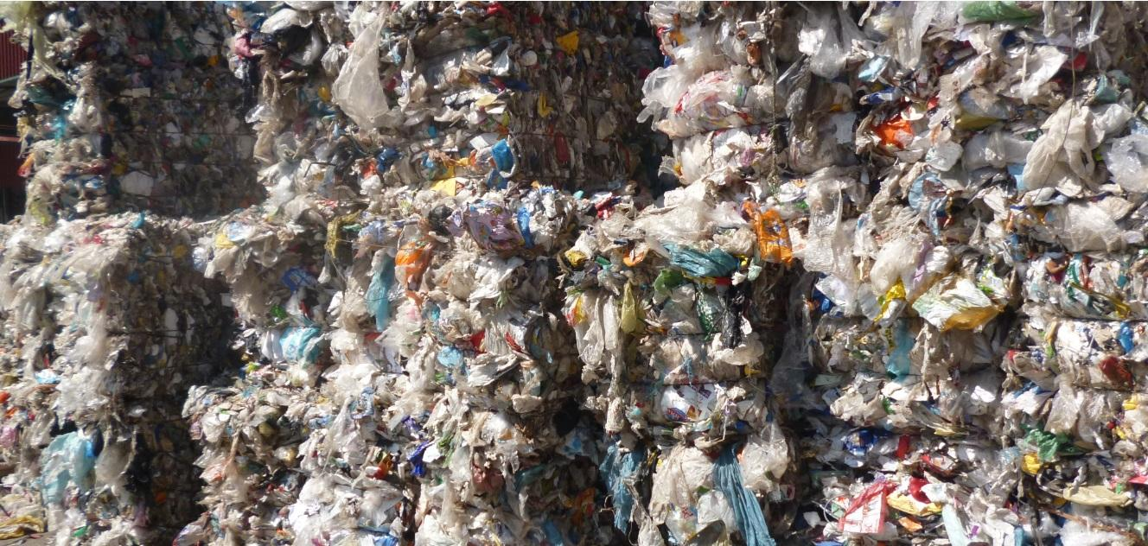

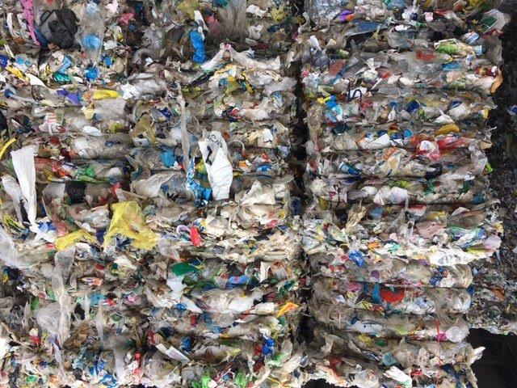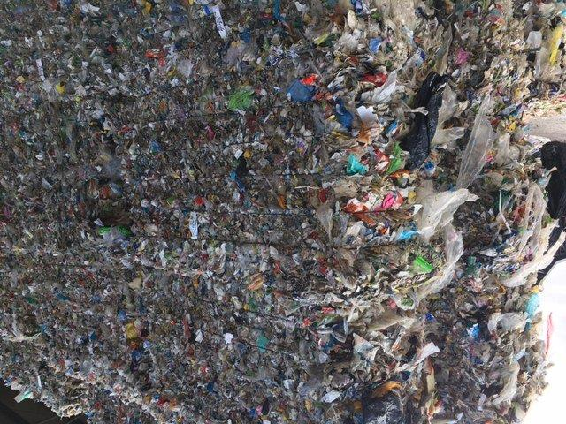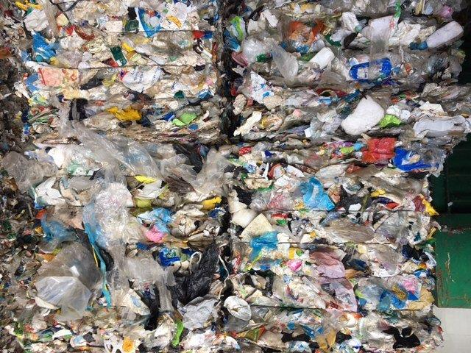
Medium Fine Coarse

Provisional Lab test report

The following report constitutes an average of five separate samplings, taken in different periods of time from the final Plasmix material produced, pursuant to UNI 9903-1:2004 sampling provisions. Being a reference only, the testing method has not been indicated.

Parameter | Indicative Value | Unit | Indicative range
Lower Heating Value | 25930 | KJ/Kg | 22000 - 27000
Moisture | 14.89 | g % (m/m) | 11- 15
Ashes | 7.42 | g % | Max 20
Arsenic (As) | < 0.50 | mg/kg | N/A
Cadmium (Cd) | < 0.50 | mg/kg | N/A
Chrome (Cr) | 4.30 | mg/kg | Max 10
Sulphur (S) | 0.014 | mg/kg | Max 0.6
Chlorine (Cl) | 1.43 | mg/kg | Max 2

temizevren@greensley.eu

www.greensley.eu

